Software Manual for
VCS: VIRTUAL COMBAT SYSTEM
v1.0

Developers:
Mert KAVİLCİOĞLU, Seda KOCAOĞLU
2025
TABLE OF CONTENTS
- GENERAL INFORMATION ...........................................................................1
  - Description of Software .....................................................................1
  - System Requirements .....................................................................
- INSTALLING ....................................................................................................2
- INTERFACE OVERVIEW …..........................................................................3
  - Map View .............................................................................................
  - Hierarchy Panel ................................................................................
  - Editor Panel .....................................................................................
  - Action Panel ......................................................................................
  - Log Panel ...........................................................................................
  - Control Panel .....................................................................................
- FUNCTIONS AND HOW TO OPERATE THE APPLICATON................7
  - Map Constraints and Entity Behaviors .........................................
    - Map Ground Types and Bounds ...........................................
    - Entity Types and Components ..............................................
    - Entity Movement Behaviors ..................................................
  - Creating and Editing Entities .........................................................
    - Entity Create Menu ............................................................
    - Entity Select and Drag ...........................................................
    - Entity Editor ............................................................................
    - Copy & Delete Entities and Revert Changes .........................
  - TDL Communications .....................................................................
  - Giving or Updating Orders .................................................................
    - Attack Order ................................................................................
    - Move Order .................................................................................
    - Follow Order ................................................................................
    - Updating Current Orders .............................................................
  - Monitoring the Logs .............................................................................
    - Message Logs ................................................................................
    - Debug Logs ...................................................................................
  - Time Controlling ...................................................................................
    - Play and Pause Buttons ................................................................
    - Changes During the Runtime ...........................................................
  - Loading and Saving Scenarios ...............................................................
    - Saving Scenarios ............................................................................
    - Loading Scenarios ..........................................................................
    - Reset the Current Scenario ...........................................................
REFERENCES .........................................................................................................
APPENDICES ...........................................................................................................

- GENERAL INFORMATION
  - Description of Software:
“Virtual Combat System” is a simulation engine that provides environment for creating combat scenarios and simulating the tactical data link communication between the entities. VCS aims to help military command & control units by providing improved operational planning with less cost and risk.

  - System Requirements:
*********

- INSTALLING
aaaaa
- INTERFACE OVERVIEW
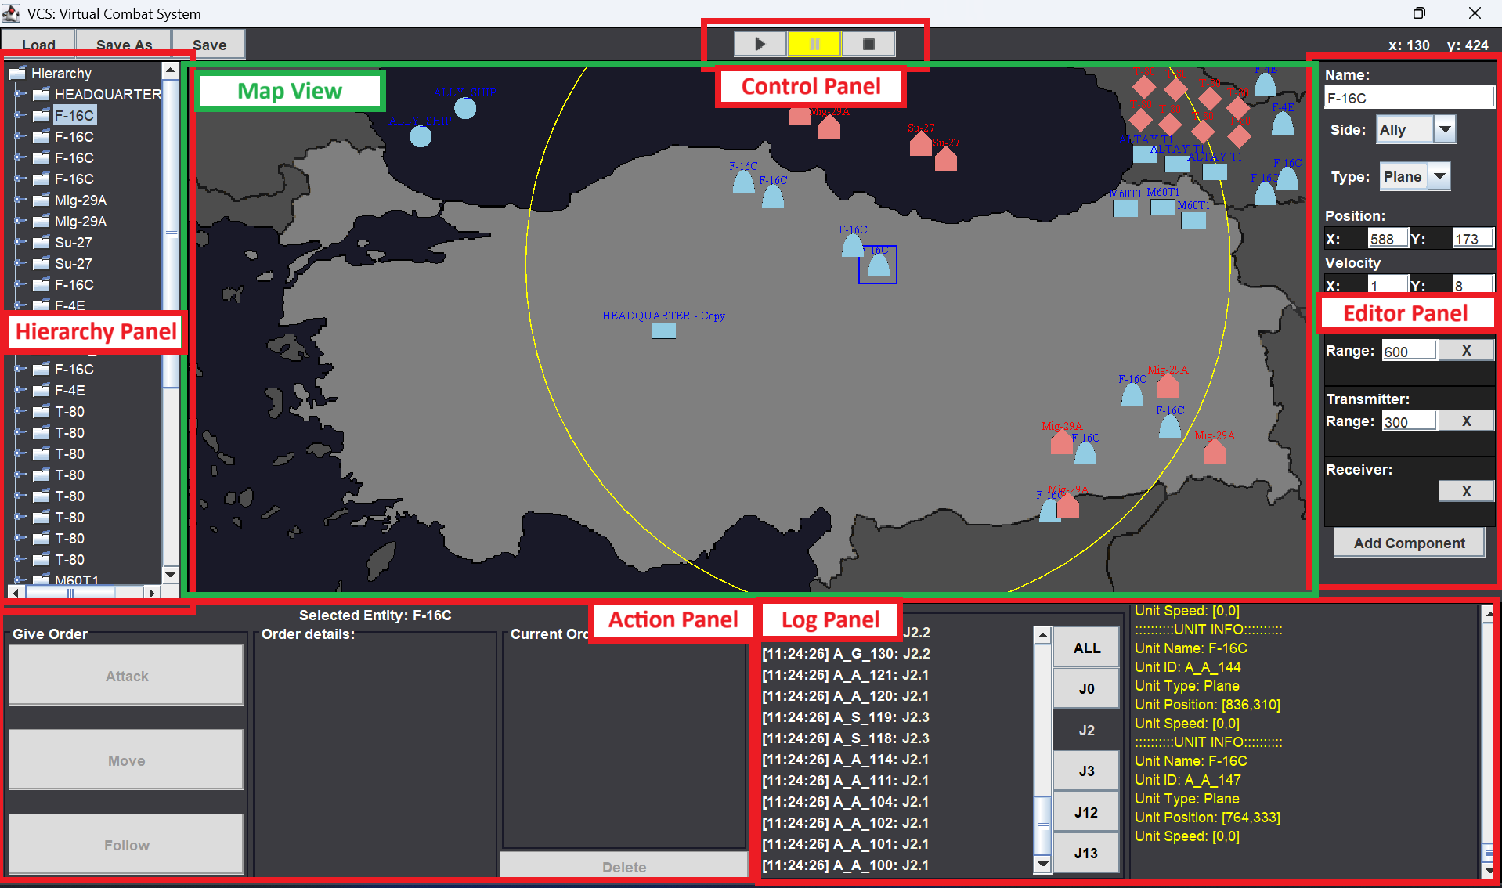
  - Map View:
This panel is the scene overview where the scenarios will be running on. Türkiye map is located on this panel and users are able to interact this panel for dragging or selecting the entities. Also, entities can be created by right-clicking on the map and selecting type and side from the opened menu. The entities are displayed with appropriate NATO military symbology and their visual are being updated regularly in order to catch any change occurred in their details or components.

  - Hierarchy Panel:
All entities and their components in current scenario are listed in a tree form on the hierarchy panel at the left of the screen. Users are able to select an entity by clicking its name on this panel or see more details about selected entity by double-clicking on the name. The data of this panel is being updated regularly to be up-to-date about the details of entities at the current time.

  - Editor Panel:
After selecting an entity, the details about the selected entity can be update through the editor panel at the right of the screen. Users are able to update the name, side, type, position, velocity, radar, transmitter and receiver components of an entity and apply these changes by pressing enter. Also; radar, receiver and components are removable and they can be re-added through the add component button.

  - Action Panel:
Attack, move and follow orders are able to be given to a selected entity through the action panel at the left-bottom of the screen. In order to receive order, selected entity must have TDL components and be in the communication range of HQ unit. Users are able to give attack order to selected entity by choosing an enemy entity who is known by HQ, give move order by entering the position vector or selecting the move point from the map, and give follow orders by choosing the follow target entity and following duration. Also, the list of orders of the selected entity is listed and these orders are able to be aborted by selecting with left-click and then using the delete button.

  - Log Panel:
At the right-bottom of the screen, the log panel is located with 2 parts. The left part shows the TDL messages transmitted by entities and by using the buttons, these messages can be filtered for displaying on this area. Double-clicking to a message opens the description and details about the message content and the content generally includes information about sender and receiver, and the reason. Message types and contents are explained in the document “TDL Dictionary v1.0”. The right panel is a debug panel and the important events or errors are displayed here.

  - Control Panel:
At the mid-top of the screen, control panel is located with buttons that used for controlling the scenario. At the mid, there are play, pause and reset buttons to start the current scenario, pause it and reset to initial values. At the left, there are save and load buttons to save the current scenario as a .txt file or load an existing scenario.

- FUNCTIONS AND HOW TO OPERATE THE APPLICATON
  - Map Constraints and Entity Behaviors:
    - Map Ground Types and Bounds:
The map is separated with 3 different ground type as land, surface and air. The description for light grey grounds is home lands, dark grey for neighbor lands, and dark blue for sea. The air zone exists on every point on the map.

    - Entity Types and Components:
There are Enemy and Ally sides and the type of these entities can be declared as Tank, Plane or Ship. All entities have name, side, type, position and velocity components by default and mandatory, and as optional components they can have radar, receiver and transmitter.

 | PLANE | TANK | SHIP
ALLY | 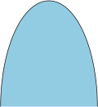 |  | 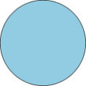
ENEMY |  | 

    - Entity Movement Behaviors:
All entities move with 2-dimensional velocity values. Tank types are able to move only on lands and ships are on to sea. Planes have no movement zone constraints but while ships and tanks are able to stay at a position after the tasks done, planes are not able to stay stationary during the flight.

  - Creating and Editing Entities:
    - Entity Create Menu:
Users are able to open create entity menu by right-clicking on the map. Through the menu, entities can be created after selecting the side and type. The entity will be created at the location where the cursor located when the user right-clicked to open the menu. Therefore, entity create has ground type constraints and if an entity type is no available to deploy on current cursor location, that type will be non-selectable.
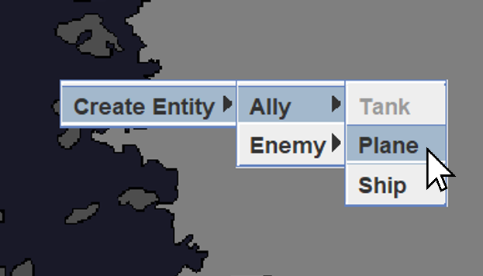

    - Entity Select and Drag:
By left-clicking on an icon of an entity that located on the map, users can select that entity. Also, left-clicking and dragging the mouse makes the entity be dragged. Dragging also have ground type constraints like movement.

    - Entity Editor:
After creating or selecting an entity, the details about the entities can be modified through that panel. If the value of a component is invalid, the panel will not allow to apply the changes when clicked the enter button and marked the invalid input area. If all values are valid, the entity will be updated successfully.

    - Copy & Delete Entities and Revert Changes:
For creating a copy of an entity, users can press CTRL + C to a selected entity and paste the clone at the cursor position with CTRL + V buttons. Pressing DEL or BACKSPACE buttons deletes the selected entity and pressing CTRL + Z buttons reverts the last change which is able to be reverted. The changes that able to be reverted are the operations on the entities such as create, update, drag, delete and copy.

  - TDL Communications:
Entities which have transmitter and receiver components use TDL network to communicate each other. This network uses messages to deliver updates or orders. The entities send their messages to the world, and all entities in range receive that message. According to the content or target of the message, the receiver entities can read, ignore or relay that message and if the receiver is the target of the message, this entity also transmits acknowledge message in a return of received message. All messaging codes and message contents are described in “TDL Dictionary v1.0” document.

  - Giving or Updating Orders:
    - Attack Order:
By clicking on the attack button at the action panel, the list of attackable entities can be listed a chose as a target for the selected entity if the selected entity is in a communication with the HQ. After choosing a target, an attack order message is being sent and after receiving the message, the receiver entity starts to execute the order.

    - Move Order:
By clicking on the move button at the action panel, the move point input areas will be opened for the selected entity if the selected entity is in a communication with the HQ. After entering a position or clicking the point on the map, a move order message will be sent and after receiving the message, the receiver entity will start to move to the target position.

    - Follow Order:
By clicking on the follow button at the action panel, the followable entities will be showed for the selected entity if the selected entity is in a communication with the HQ. After selecting a follow target entity and entering the follow duration, a follow order message will be sent and after receiving the message, the receiver entity will start to follow the target for entered time duration.

    - Updating Current Orders:
The current order list of the selected entity is listed on the action panel. An order can be selected by left-clicking and can be deleted by pressing delete button after it selected. However, making modifications about the content of a given order is not possible.

  - Monitoring the Logs:
    - Message Logs:
The TDL messages transmitted during the runtime are displayed on the left part in the log panel. The display format includes transmit time, transmitter UID, and the message code. By using the buttons with codenames, the message list can be filtered for display. By double-clicking a message, the content of message can be displayed as a popup.
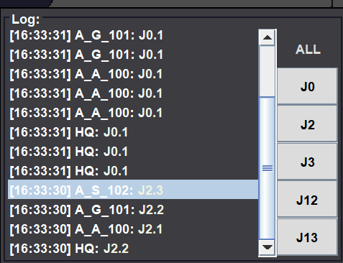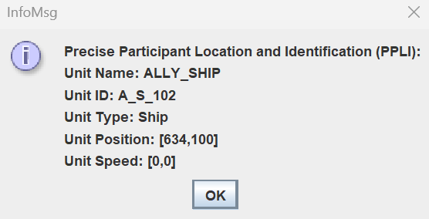

    - Debug Logs:
Important events, system messages and errors can be displayed on the debug log panel for improving the engine use or development feedbacks.
  - Time Controlling:
    - Play and Pause Buttons:
The current scenario can be started by pressing play button. During runtime, pressing the pause button will pause the scenario.

    - Changes During the Runtime
During the runtime, the changes on the entities occurred by either other entities or the user will be temporary, and after resetting the scenario, the entities will be back to their initial status at the saved scenario.

  - Loading and Saving Scenarios:
    - Saving Scenarios:
To save the current scenario as a text file, users can press “save” or “save as” buttons. Save button will save the scenario on current running text file and save as will save the scenario as a new text file.

    - Loading Scenarios:
To use an existing scenario, users can press the load button and choose a valid text file which includes a scenario detail in a specified format that used for saving.

    - Reset the Current Scenario:
During the runtime, users can press the reset button to turn back to initial point of the current saved scenario.

